**PROJECT MANAGEMENT PLAN**

***BLOOD BANK DATABASE MANAGEMENT SYSTEM (BBDBMS) by WomenInTech***

|  |
| --- |
| **1. ROJINA SABERI 217354051**  **2. ADINA ASIF 215691801**  **3. KECHINYERE EMEROLE 216853582**  **4. ELSIE BENKO 217963190**  **5. KLARA GOLUBOVIC 219989573**  **6. NOSHIN ISLAM 216801219** |
|
|
|
|
|



**National Project Management System**

**Business Projects-IT-Enabled**

**Planning Phase**

**Revision History**

| **Version Number** | **Description** | **Date Modified** | **Author** |
| --- | --- | --- | --- |
| 1.0 | Project Management Plan | 11/28/2022 | Women In Tech |
|  |  |  |  |
|  |  |  |  |
|  |  |  |  |
|  |  |  |  |
|  |  |  |  |

**Table of Contents**

**1** **Executive Summary 6**

**2** **Integration Management 6**

2.1 Project Governance and Project Team Structure 6

2.2 Roles and Responsibilities 7

2.3 Change Management 7

2.3.1 Change Control 7

2.3.2 Issue Management 7

2.4 Project Close Out 8

**3** **Scope Management 8**

3.1 Scope Statement 9

3.2 Requirements Management 9

3.3 Project Deliverables 9

3.3.1 Work Activities 9

3.3.2 Requirements Control 9

3.3.3 Constraints 10

3.3.4 Assumptions 10

3.3.5 Stakeholders 10

**4** **Schedule Management 10**

4.1 Milestones 10

4.2 Schedule Control 10

**5** **Cost Management 11**

5.1.1 Estimation 12

5.1.2 Budget Allocation 12

5.1.3 Budget Control 12

**6** **Quality Management 12**

6.1 Quality Assurance 12

6.2 Quality Control 13

**7** **Human Resource Management 13**

7.1 Human Resources Acquisition 13

7.2 Human Resources Development 13

**8** **Communications Management 13**

8.1 Stakeholder Analysis 13

8.2 Project Reporting and Communication 14

8.3 Metrics Collection 14

**9** **Risk Management 14**

**10** **Procurement Management 14**

**11** **Stakeholder Management 15**

**12** **Team Contribution Composition 15**

**13** **Description of Revisions 15**

**14** **References 16**

# Executive Summary

This project aims to devise and strategize a system that deals with the concerns of developing software for a blood bank(s) database management system. A blood bank stores blood collected from donors, along with the necessary data and information about the blood and the donor it is collected from, then prepared for transfusion to recipients (Davis, 2021). Problems arise when hospitals are required to retrieve the necessary data to match the blood type of recipients requiring a transfusion in a timely manner. Hospitals are often unable to meet the demands due to blood shortages of specific blood types, especially rare ones (Younis, 2020). This project aims to solve such recurring problems by designing and implementing a software that utilizes a database management system, allowing respective access to donors and hospitals based on profile criteria and agenda. Donors can directly retrieve information regarding their previous blood donations, including their blood results and donation history, in order to easily schedule their next appointment (Shah, 2020). They can also update their personal information through the system, without having to contact the blood bank registry, while on the other hand, hospitals are able to keep track of the different types of blood available and track nearby hospitals with relevant blood types in stock (WomenInTech - Project Proposal, 2022).

The project plan includes each of the 10 Project Management knowledge areas, which cater to the end user’s specific requirements. Depending on the end-user, the application will narrow down the user interface to provide accurate and timely details about blood reserves that could potentially save someone’s life. Hospitals can request the type of blood they require while also being able to view what is available and its whereabouts depending on the hospital’s location. This is an essential consideration as often the location may be in remote areas where finding a blood match is difficult. In the back end, we aim to strictly regulate the donor’s profile, which outlines their medical history as the hospital needs to be aware of any illnesses they have/had (WomenInTech - Project Proposal, 2022).

Our mission is to provide an easy-to-use/accessible platform to donors and hospitals. We aim to provide a secure way to access donor history and timely updates regarding bloodstock that is available at the hospital by which they are always informed and can quickly check/have access to stock level. Additionally, donors no longer need to be called/emailed or contacted individually regarding their blood report. Our software allows them access to their test results as soon as it is available and get notified if there is ever a shortage of a blood type specific to theirs and urgently required by the hospital (WomenInTech Project Proposal, 2022).

Our problem statement is that hospitals currently document information regarding blood donation information in a manual manner. The process of donating blood includes the carrying of a blood donor ID. After the first time donating blood, this ID is handed out to the donor for the next time they come back. This ID card holds all the information about the donor’s blood and their last appointment and can identify them (Canadian Blood Services, 2022). However, with this idea of a physical ID card comes many problems. The cards can get lost, stolen, or damaged - in all those cases, the donor must make a replacement to keep his membership (Moiz Ali Shah, Syed. Malick, Hammad, 2020) (WomenInTech - Project Proposal, 2022).

Hospital staff often need to learn the number of blood banks, what type of blood, and where those blood banks exist. Furthermore, another problem is that updated information about the donors still needs to be communicated by calling or emailing, which we aim to resolve with our BBDBMS (Canadian Blood Services, 2022). Our mission is to provide an easy-to-use/accessible platform to donors and hospitals. We aim to provide a secure way to access donor history and timely updates regarding bloodstock that is available at the hospital by which they are always informed and can quickly check/have access to stock level (WomenInTech - Project Proposal, 2022).

# Integration Management

Project Integration management is the key to overall project success as it crosses all phases of the traditional project life cycle namely: Concept, development, Implementation and close out. The project manager has the responsibility of coordinating all the people, plans, and work required to complete the project and ensuring that all the integration processes are completed. (Schwalbe, 2018). The project manager must communicate well with all project stakeholders, including customers, the project team, top management, other project managers, and opponents of the project. Project integration management will be coordinated through these processes:

1. **Developing the project charter**: The project charter formally recognizes the existence of the Blood Bank Database Management System project and provides direction on the project’s objectives and management.(Schwalbe, 2018). The project manager will develop and work with the key stakeholders involved in the project, which include the customers, Hospitals, Health Ontario, the Ontario government, and other internal customers to create the project charter that will formally authorize the Blood Bank Database Management System project. The project charter authorizes the right to use the organizational resources to complete the project; the key project stakeholders would also sign the project charter to agree on the need and intent of the project. The inputs of this process include the business documents, agreements, organizational process assets. Tools and techniques include expert judgement, interpersonal and team skills and meetings.
2. **Developing the project management plan**: This step involves coordinating all planning efforts to create a consistent, coherent document that acts as a blueprint to stakeholders and end users surrounding the execution of the project. (Schwalbe, 2018). This outlines the communication tools and protocols, the risks involved, stakeholders and their roles, the benefits of the project and the deliverables: the database, the website for hospital clients and the software for hospital use. The team will put together the risks involved, assess the scope and milestones to avoid scope creep, develop a risk management plan and assess the resources needed to complete the project, such as the human resources, software, monetary funds and so on.
3. **Directing and managing project work** This process involves carrying out the project management plan by performing the activities included in it. (Schwalbe, 2018). The team will act on the project management plan, organizational project assets, approved change requests, project documents and enterprise environmental factors. The outputs will include the issue log, change requests, work performance data and the deliverables: the database system, the software and website for clients.
4. **Managing project knowledge** involves using existing knowledge and creating new knowledge to achieve project objectives while also contributing to organizational learning. (Schwalbe, 2018). It is about using existing knowledge within the organization to achieve the project’s objectives and then using new knowledge gained on the project to contribute to the organization’s body of knowledge. This knowledge includes awareness and expertise in hospital practices, blood types, patient demographics etc.
5. **Monitoring and controlling project work** involves overseeing activities and tracking project performance and actively reviewing the status of the project as it proceeds to meet the performance objectives of the project. (Schwalbe, 2018). At this phase the project team will make sure that the scope is contained to avoid scope creep, the project stays within budget, risk is managed, and the schedule is followed. Potential success and failure of the project is assessed at this phase.
6. **Performing integrated change control** involves identifying, evaluating, and managing changes throughout the project life cycle such as reviewing the change requests and approving changes to deliverables and project documents. (Schwalbe, 2018). This process ensures that any changes made to the project must be tracked, identified, decided on, and documented. The change requests may include corrective, preventive and detective action and repairs. Changes proposed are reviewed and approved before they are implemented into the project. The change requests, work performance reports, project management plan and other important documents are input to result in approved change requests, project management plan and project document updates.
7. **Closing the project or phase** involves finalizing all activities to formally close the project or phase. The inputs for this phase are procurement documentation, business documents, the accepted deliverables, the project charter and the project management plan. The goal of this phase is to produce the final products: the website, the software and the database. This process will also include the final report and the organizational assets updates.

Software will also be used to enhance project integration management such as:

- Word processing software to create documents

- presentation software to create presentations

- Spreadsheets for tracking

- Communication software to facilitate communications

## 2.1 Project Governance and Project Team Structure

**Organizational Boundaries**

The Organizational boundaries in this project will distinguish one group from the other, such as the project team that encompass the project manager, as well as contracted IT professional like the UI/UX designer, software developer, financial analyst, system integrator etc. and the external entities such as the government and Health Ontario, as well as the roles and responsibilities of each group. The internal operations will be differentiated from the external activities in the sense that all the people involved in and affected by the project will be in the internal or external stakeholder category.

**Communication with Senior Management, customers, marketing, legal, finance, procurement, certification bodies, auditors**:

Communication within the steering committee and internal stakeholders will be mainly informal, and reports and other documentation can be shared through email or web pages. The informal discussions will be key to developing good relationships between each other. While communication with external bodies and government entities related to the project such as Ontario Health, PHIPA, Medical Devices Bureau, OHIP, EHR (Electronic Health Records) bodies can be discussed more formally in meetings with their respective representatives. License agreements can also be communicated through email.

Communication with the clients will be in the context of user acceptance testing, through studying them in their context (hospitals) can be done through virtual environments such as video conferencing, instant messaging, and other technologies to communicate the necessary information. Communication with this group can also be done in focus groups in person. Communication can also be enhanced through defining schedules, suggested methods for conveying information, communication requirements and information to be communicated.

**Functional Organizational Breakdown Structure**

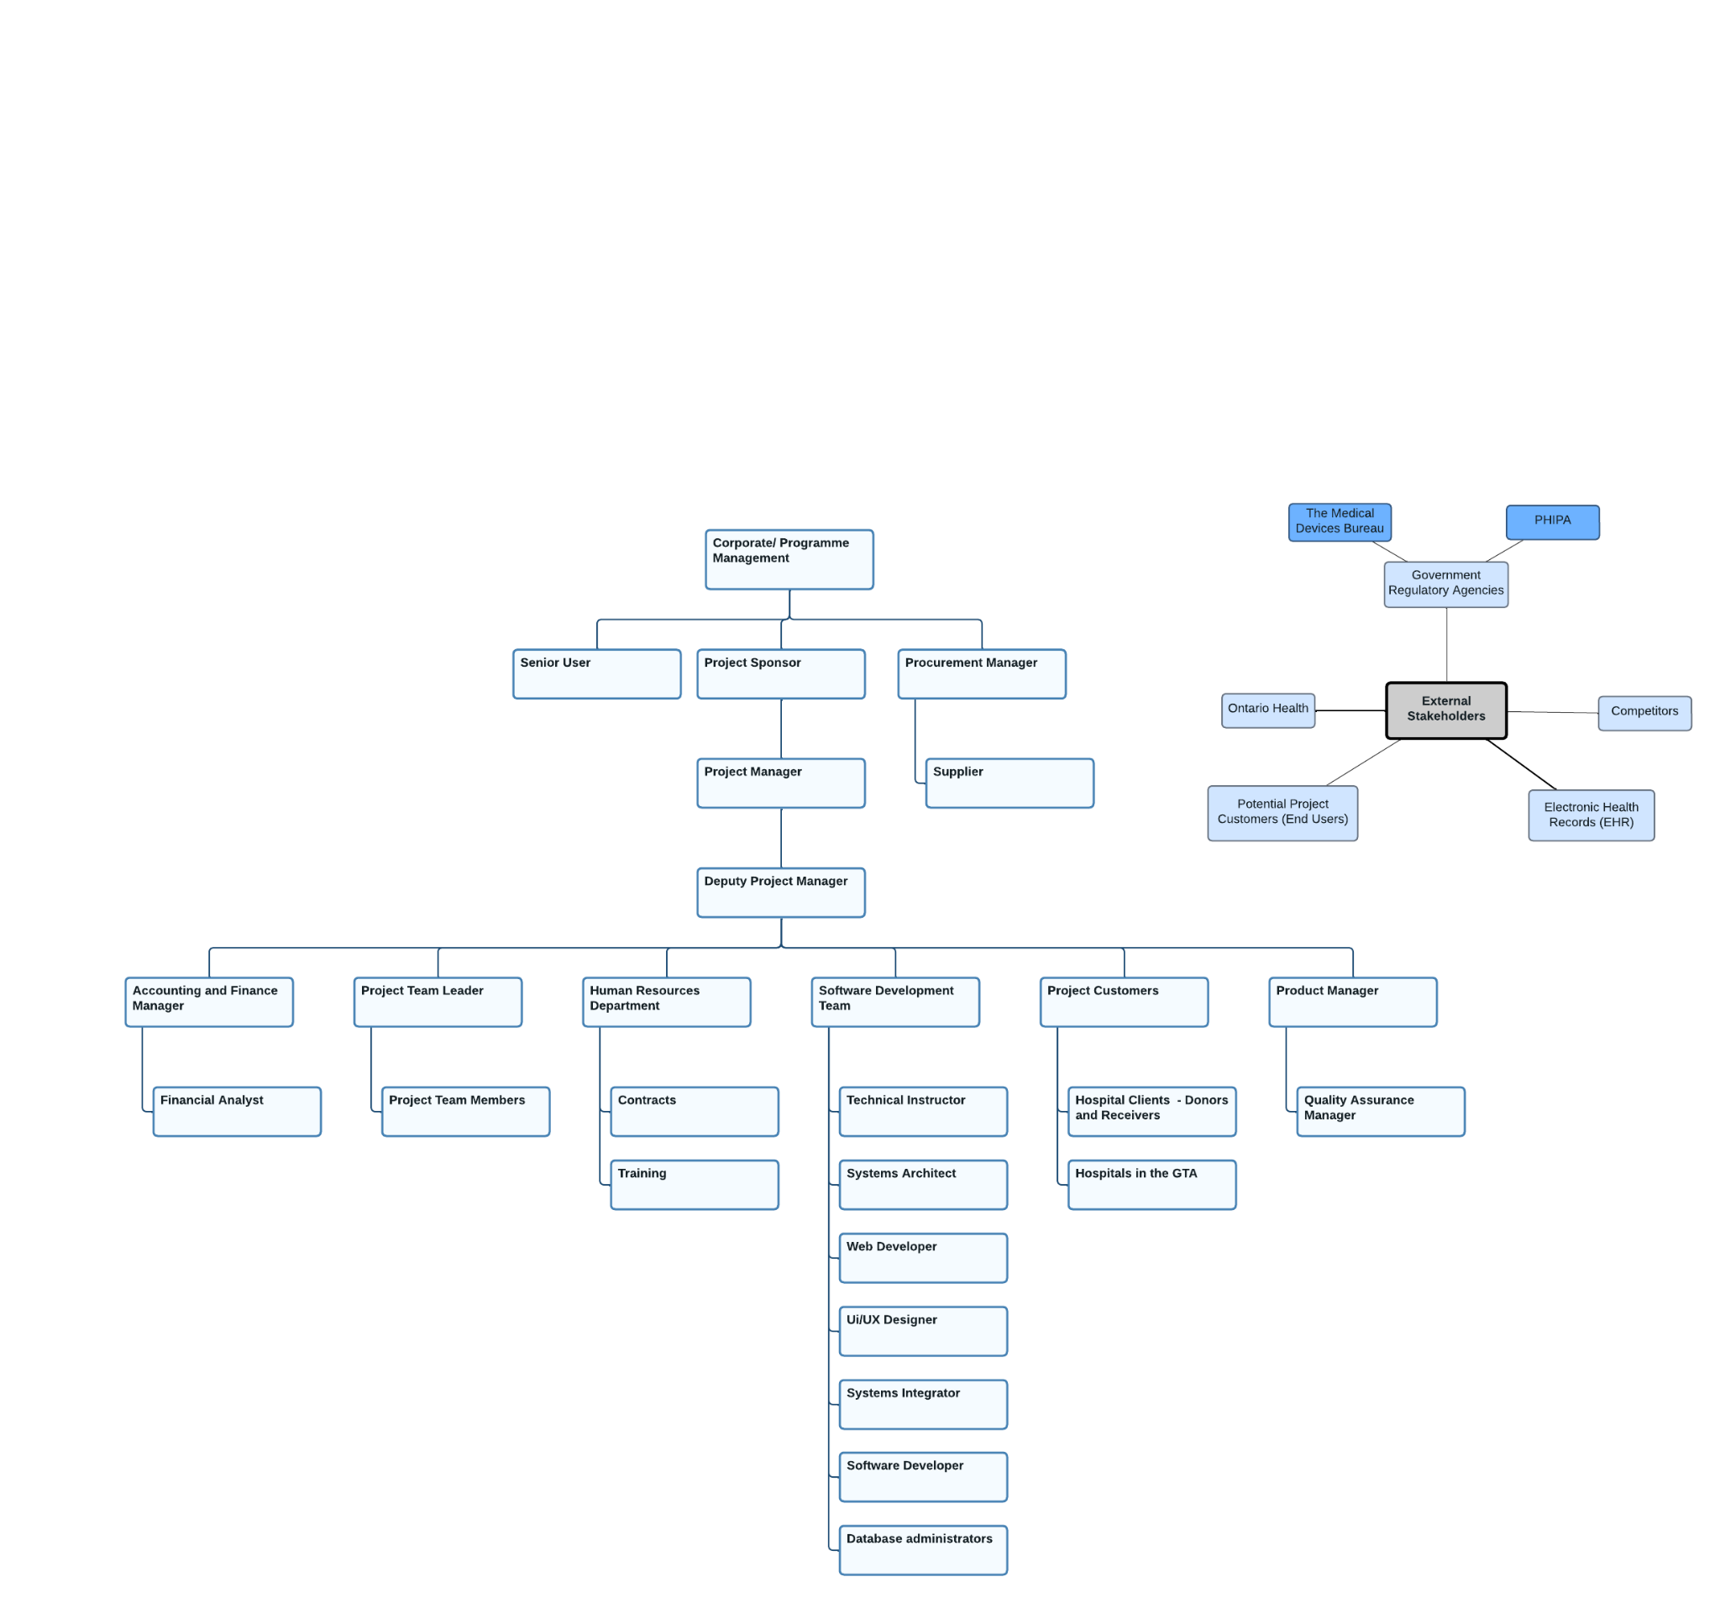

## 2.2 Roles and Responsibilities

· **Project Manager**: The project manager oversees planning, executing, and ensuring the completion of the project. The project manager will be involved in the planning process, monitor project progress and changes, and ensure all the objectives towards creating the BBDMS and its deliverables are fulfilled. Their interaction for the project will be throughout the project life cycle.

· **Software Development Team**: They will create the BBDMS software and application by deploying, designing, building, and maintaining the software. They are involved in the front end and back-end items of the work breakdown structure.

· **Database administrators**: They will oversee developing and maintaining the database of clients and hospitals which encompass all the information about client’s demographics, blood type, location, height, existing health issues etc. They will be tasked with protecting this sensitive information, backing up, updating, and managing new data as well as archiving old information.

· **Financial analyst**: They will track the project's company’s financial performance against the business plan, analyzing the project performance and market conditions.They are the specialists who will handle all the accounting tasks related to the project, such as financial statement analysis, audits, or account analysis.

· **Human Resources Department**: They oversee managing all the project employees by hiring, training, onboarding, and developing.

· **Product Manager**: The product manager describes what success looks like for the BBDMS deliverables, pinpoints the consumer need and bigger corporate goals that the website and application features will address, and rallies the team to make that vision a reality.

· **Project Customers**: The project customers encompass hospitals in the GTA and their clients.

o **Hospitals in the GTA**: They are among the end users the BBDMS has been created for. They are on the receiving end of the project and will be involved in user acceptance testing on the part of the software. They will also be in charge of registering themselves with the software so that all their patient data can be synched in the database, and they will be able to take advantage of the benefits of the BBDMS. They will also act as a focus group where project team members and user interface designers can observe them in their context so as to provide high-quality software that meets their needs.

o **Hospital clients**: They will be able to access the client side of the BBDMS through our website where they can see updated information on their blood test results and receive notifications on the availability of blood in the hospital or nearest blood bank as blood receivers.

· **Project Team members**: They are part of the steering committee and encompass business analysts as well as professionals and subject matter experts on health care and Blood bank management. They actively work on several phases of the project and document the process.

· **Systems integrator**: In charge of maintaining and building the system for this project by combining subsystems into one integrated solution.

· **Systems architect**: They will write the code and enforce the standards for the software developers to ensure performance, security, and scalability of the applications.

· **Technical instructor**: Their role will be more significant in the testing and training aspect of the project. They will supervise the teaching hospitals the capability of the BBDMS software and how to realize its full potential. They will prepare the technical documents and training reports.

· **UI/UX designer**: They are in charge of the overall user interface for two IT project deliverables that will interact directly with end-users: the website for hospital clients and the application for hospitals. They will make prototypes of these products by collaborating with product managers and engineers to gather requirements from users to use as a baseline for enhancing user experience. They will work with the web developer, clients, project team members etc. to get the desired results that meet the project standards.

· **Web Developer**: A web developer oversees coding, designing, and laying of the BBDMS website in accordance with the requirements of the project. They will be the ones to design the client's view of the system.

· **Steering Committee**: This consists of executives who will examine the project and its problems. Weekly meetings of the executive steering committee will be held to review BBDMS development and plan work for the coming week. The chairman of the Project Management Office is a member of this committee along with managers from several departments. The committee includes managers from outside the IT department and has the purpose of assisting IT staff in creating a strategic plan and choosing which business areas to serve.

· **Suppliers**: These are the groups of people in charge of providing the technical equipment that will be needed by the project team members to realize the project objectives. They will supply the project team members with keyboards, desktops, laptops, installation of new operating systems and other software.

· **Project sponsor**: The project sponsor is an important stakeholder that has invested resources into the project. They prioritize the project and provide support.

**External Stakeholders:**

· **Competitors**: They are materially affected if the BBDMS is successful. They are the companies which offer similar services as the BBDMS that will be affected by the higher sales and margin of the BBDMS project.

· **Government regulatory agencies**: The project is encompassed in a field that is heavily regulated. (Healthcare). The project team will have to deal with government regulators and departments as well as permission to execute the deliverables. The government bodies will include the following:

o **PHIPA**: PHIPA stands for the Personal Health Information Protection Act. They establish rules for collection, use, and disclosure of personal health information. The BBDMS will be required to obtain personal health information from its clients and hospitals, so the project will need to obtain the consent to collect and store this information.(Develop App Like Oscar Healthcare App + PHIPA Requirements, 2020)

o **The Medical Devices Bureau**: They are the Canadian federal regulator that is responsible for licensing medical devices in accordance with the medical device regulations.

· **EHR (Electronic Health Records):** The BBDMS database requires fetching data from other health care providers such as clinics, laboratories, and hospitals. The database will be integrated with a trusted Electronic Health Records system, which gets patients blood-based data such as demographics, blood group, medical history etc.(Develop App Like Oscar Healthcare App + PHIPA Requirements, 2020)

· **Ontario Health**: They are the provincial body established to connect, coordinate, and modernise the healthcare system in Ontario. They oversee the healthcare delivery and will be one of the government bodies for obtaining permissions to release the BBDMS deliverables for public use.

· **Potential customers (End Users)**: They are the people who are not directly involved in the focus group used for user acceptance testing or the hospitals themselves but have an interest in the BBDMS project website and application for their own benefit.

## 2.3 Change Management

The most important part of integration is change management. Change management is best organized with a change management plan. The document will encompass activities or roles that will need attention during the life cycle of the BBDMS project. The procedure used to start, document, evaluate, approve, and resolve project changes is known as the change management process. When it is deemed necessary to alter the scope, timeline, or price of one or more previously agreed project deliverables, project adjustments are required.

**Change Management Process:**

· Establish the goal of the change: Having a clear scope of what needs to be changed in the project to avoid scope creep. Resources and individuals needed to drive change will be identified in this phase.

· Plan the change: The blueprint that contains in steps the details of the change process which include the path that would be taken and the desired end result. It includes costs, training equipment and IT systems required.

· Establish new benchmarks: This is needed to track progress though targets and incentives. To maintain momentum and let stakeholders know how the process is going, it is also possible to develop relevant progress reports by setting clear benchmarks and monitoring progress toward milestones and targets.

· Communication: Transparent two-way communication gives all parties involved: stakeholders, project team, sponsors, Health Ontario etc. a real way to understand what is working and what isn't, allowing them to be responsive and test out new ideas.

· Evaluate and continuously improve: Change management should be done iteratively. A requirement for measurement and analysis is needed to measure achievements.

**Roles and Responsibilities:**

· Project Manager: The Project Manager receives, logs, monitors, and controls the progress of all changes within the project. The Project Managers are responsible for:

Identifying the requirement to make a change to the project

Documenting the requirement by completing a Change Request Form (CRF)

Submitting the Change Request Form to "Blood Bank Database Management System" Leadership for review.

Organize change management meetings

Ensures changes comply with the change management system

· Financial Analyst/ accountant: Provides cost control assistance to the change control process.

Updates the cost system, budgets, and commitments with approved changes

Provides the cost report budget vs revised budget

Reports the impact of all approved potential variation notices on the cost and schedule forecast.

· Software Development team, UI/UX Designer, Systems Integrator: Reviews changes submitted for compliance with project coding systems.

. Change control board (CCB): This is a formal group of people tasked with approving and rejecting changes. They will evaluate change requests and manage the implementation of approved changes

**Tools and Techniques:**

· Assessments: Assessing impact can be done on the Individual or departmental level. Assessments can be done through:

· Interviews with clients to update the project requirements to ensure that is fulfilling the need for which the product was created.

· In focus groups, a small selection of the IT department can give feedback on the user acceptance testing done on the prototypes of the website and application.

· Surveys and questionnaires can collect and analyze information from all members of the project team as well as the client on what works and what doesn’t.

· Flowcharts: This helps the project manager and project team members to use a diagrammatic expression to understand what is changing.

· Gantt Charts: All changes to the schedule can be updated in the Gantt chart.

**Reporting**

The change management status report will include:

- The project name

- Time period

- Project Manager

- Overall status

- Change description

- Change reason

- Change Impact (scope, time, budget)

- Group assigned the change

- The percentage of successful changes.

### 2.3.1 Change Control

**Integrated change control** is a form of accountability, monitoring and auditing and involves identifying, evaluating, and managing changes throughout the project life cycle. It is a formal document that will outline a request for change. As opposed to change management, change control will deal with how changes are established in the project. (Westland, 2022)

Important inputs to the integrated change control process include the project management plan, project documents, work performance information, change requests, enterprise environmental factors, and organizational process assets.

**Change control Process:**

- **Change governance**: The CCB (Change Control Board) is the main decision-making body for all the change requests. Once they receive a change request, they will meet regularly with the project sponsors and steering committee to address the change.

- **Change identification and request management:** This encompasses proposing a change and requesting the procedure to start, document and maintain a change. Proposing a change is identifying the change as the first step. Any member of the project team, a stakeholder, or even a client requests change. The change proposal would outline the modification and its potential advantages for the project. Change request management documents a formal petition for change and explains what changes are to be made and why they should be implemented.

- **Impact analysis**: It is up to the project manager to consider how the change will affect the larger context of the project in terms of the constraints. How will the change impact the schedule? Would there be a new government body that the project may request license and permission from? Would more resources be employed? And would new risks and issues arise? Impact analysis analyzes the effectiveness and efficiency of the change process.

- **Change approval process:** After careful evaluation, the authorized members of the team decide whether to implement a change or not. A list of sponsors, stakeholders and key-decision makers will be made to get their approval officially.

- **Implement change:** If the change request is approved, the process will move on to the implementation phase. A change that has been approved will need a planned schedule where all the necessary members of the project team must meet with the stakeholders. If the change is approved, tasks may need to be rescheduled, the WBS would need to be updated and additional resources may be requested.

- **Review/reporting:** The teams should conduct a review following implementation to ascertain whether the project is still on track. It may happen during the project's closing procedures or during the following stakeholder meeting after implementation.

- **Change tracking:** Monitoring the change to ensure that the corrections have been implemented and identify any risks that need addressing. (Brown, 2021)

### 2.3.2 Issue Management

The aim of issue management is to recognise, record, and then address concerns by carefully analysing and weighing all pertinent data. Conflict that arises from unresolved issues can impede or delay the project team's ability to complete milestones, deliverables, and project goals. Throughout the project lifecycle, issue management is crucial for preserving the stability and effectiveness of the project. (*PMG | Issue Management - Description*, n.d.)

Project issue management includes utilizing the outputs from the project risk management planning if the issue was identified as a risk during the risk planning processes.

**Process to capture and maintain information on all issues:**

An issue log is frequently used to record issues that come up when managing the project and the project team. The project team will use the issue log to track and manage issues until resolution. Issue log is one of the outputs of project integration management

This log contains:

- Issue ID or number

- Issue description

- Impact of the issue

- Date the issue was reported

- Who reported the issue

- The priority of the issue

- Issue status

- The assignment of each issue to one or more people for resolution

- A deadline by which the problem must be fixed

- Comments and other relevant data.

**Classification and Prioritization of issues based on impact:**

**Documentation** – No matter how insignificant they may appear to be, all issues should be centrally recorded using an issue tracking system or the issue log.

**Minimum Requirements** - A unique identification number, priority, issue description, impact summary, action steps, current status, and issue owner should all be included in issue management tools, at the very least.

**Resolution Statement** - Issues should be stated in such a way that it is clear how they can be resolved.

**Prioritization** - Prioritized issues should have designated owners, documented future steps, and deadlines. Clear communication of issue ownership to individuals in charge of action items is necessary. Priority ratings can be low, medium or high.

**80/20 Rule** - The "80/20 rule," which states that around 20% of the issues that are reported will cause 80% of the project's impact. The majority of mitigation measures will be concentrated on problems that could be the biggest threats to the project's success.

**Regular Review** - Reviewing issues and the issue log on a regular basis is strongly advised. Complex projects should have daily reviews, whereas basic projects should have reviews at least once per week. At each project team status meeting, open issues should be evaluated, and any developments should be noted in the issue log.

**Issue History** – Issues that have been resolved should still be recorded in the issue log for historical purposes and to help with lessons learned activities.

**Escalation process when an issue cannot be resolved:**

**Escalation Process** – An issue escalation process should be determined as a part of the overall issue management planning activities and should be documented. Higher level authority should be notified of issues that are struggling to meet a resolution, especially if the issue is beyond the project manager’s authority.

Method of escalation:

- Formally inform the decision-makers about the problem.

- Analyze the source of the problem and potential project impacts.

- Provide options for problem resolution and highlight the advantages and disadvantages of each.

- Present the situation and options to the decision-makers with recommendations for the best path forward.

- Explain what will happen to the project if no decision is reached.

- Document everything.

## 2.4 Project Close Out

**Closing Projects or phases**

The final step in project integration management is this. It entails wrapping up all activities and assigning the right people the cancelled or finished work.

Inputs of the close-out phase include Project charter, Project management plan, Project documents, Accepted deliverables (Website, database, BBDMS application), Business documents, Procurement documentation, Organizational process agreements assets. (Change Management Tools and Techniques: The Complete List, 2019)

The close-out phase will produce: Project documents updates, Final product, service or result transition, Final report, Organizational process asset updates.

**Close out plan:**

**Staff reassignment plan**: This is moving an employee within the same organizational unit to another unit that may include changes in duties, work location, which may be temporary or permanent. The contracts will be closed once the clients have approved the deliverables and the project hand off is finished. All parties will verify that they have been compensated and no invoices are owed. Project team members should be notified of any type of transfer of ownership of any outstanding project deliverables.

**Plan for archiving project materials**: Following project completion, all project documents might be revised, designated as final versions, and stored in the organization's records management system. This is done after the project deliverables have been completed and handed off to the client. All documentation: contracts, project plans, scope outlines, costs, schedule etc. will be indexed in the company archive for later reference.

**Plan for post-mortem debriefings of project personnel:** This is a time to review the successes, challenges, and failures of the project. A performance review will be conducted to calculate the project performance in terms of the triple constraint. (7 Steps to Nail the Project Management Closure Process | Lucidchart Blog, 2019). These questions will be considered:

- Did the BBDMS project stay within budget?

- Did the Women in Tech team use their time effectively?

- Were there any compromises along the way?

- How well did the project fit the needs of the client?

**Preparation of a final report to include lessons learned**: Key outcomes of the closing process group are formal acceptance of the work and creation of closing documents, such as a final project report and lessons-learned report. The final report is a summary of the project performance. It includes information such as:

- Scope objectives, the criteria used to evaluate the scope, and evidence that the completion criteria were met.

- Cost goals, such as the acceptable cost range, actual costs, and the causes of any discrepancies.

- A brief summary of the data used to validate the final good, service, or outcome.

The lessons learned report will consider the accomplishments and shortcomings of the project. Project lessons will be archived because they may be valuable to the project team in future if the team decides to undertake a similar project.

**Analysis of project objectives achieved**: The Women in Tech team works to secure acceptance of the deliverable and bring the phase or project to a successful conclusion during the closing stages.

# Scope Management

Throughout our business the management of our scope plays an important role as we are dealing with a huge amount of private data of hospitals and patients. Managing the scope of our Blood Management System means planning the scope, collecting the requirements that are involved, defining it, creating a WBS, validating and controlling the scope. We already created the WBS and the WBS dictionary. During the development and discussion of our product we also defined our scope.

## 3.1 Scope Statement

Our Blood bank database management system includes two main elements. We will provide a website that can be used by our blood donors and hospitals. In addition to that we provide software for the hospitals to use on their wokring devices.

Product Characteristics and Requirements

1. The software that we develop is meant only for the hospitals to install for offline usage. In case they cannot go on the website because of some technical or internet issues, they are still able to use the software which also works offline. The features and functions of those two elements include the integrated database that can be accessed by the hospital.
2. Hospitals should be able to look up for blood of donors that is required through either the website and the software. By typing in the blood-id into our systems, they return where in Canada this type of blood is available and who the potential donors are. The hospitals get the information about the donor or the hospital with the donated blood to get in contact so that a donation of blood for urgent cases can be realized as fast as possible.
3. The donors should be able to register after their first blood donation on our website to get information about their blood type, the next appointments and updates concerning the process of blood donation. They also get informed in case of a request for another blood donation if their specific blood type is needed.
4. Our blood bank database includes personal data about the donors as well as information about the hospital. One of our main tasks is to manage, control and secure the private data. This requires the involvement of software developers, database administrators, software engineers and test managers who need to set up the database and integrate it with our software. Furthermore, the website and the software need to be hosted and managed. The scope of our project includes creating and hosting the website as well as the software. Therefore, we need to monitor and constantly update the data that is dealt with.

| **Activities In Scope** | **Activities Out of Scope** |
| --- | --- |
| Software and Website Development (Front-End and Back-End) | We provide the contact information of potential donors, but we do not initiate and take care of the communication |
| Creating a software for hospitals that can be used online and offline | Advertisement and marketing of the website/software - We are sponsored and supported by the government and our Blood Bank database system is part of the blood donation process |
| Hosting, integration and monitoring our database | N/A |
| Management, security and control of website, software, and database | N/A |
| Project management (Planning & Initiating, scope definition, systems analysis) | N/A |
| Requirements management (Define Process and Gathering requirements, Define Risks, declare financials, coordination and Communication) | N/A |
| Portfolio, Process, Organizational and Performance Management Systems | N/A |

## 

## 3.2 Requirements Management

To collect and specify our requirements we would interview our stakeholders such as hospitals to develop the most fitting software and website for the according needs. Being in contact with our stakeholders will help finalize our requirements and prioritize them. Another way to collect our requirements will be questionnaires and surveys for the usability of our software and website. We want to offer our users an optimal handling with our systems.

After collecting requirements for the software as well as the website, we prioritize them and establish a Requirements Traceability matrix to track our requirements throughout the project. It can show us important dependencies and help us manage them. To prioritize our requirements, we will be required to have frequent group meetings of our development team and we will follow the agile approach of Scrum. Using tools such as Jira or GitLab we will track our tasks and requirements to keep up to date.

Furthermore, we will record changes to requirements in our management of requirements. If we have certain changes, they will be reported, coordinated, and controlled. Especially for Software and Website development an overview about all the requirements, their changes and dependencies are important to track and monitor a controlled implementation of our project. Furthermore, it is important for us to have good configuration management to “[identify] and [control] the functional and physical design characteristics of [our website and software] and their support documentation” (Schwalbe, 2019).

## 3.3 Project Deliverables

The green rows are project management deliverables, and the yellow rows are for project deliverables.

| **Deliverable** | **Recipients** | **Delivery Date** | **Delivery Method** |
| --- | --- | --- | --- |
| Business Case & Plan | Project manager, Project team | 21.11.2022 | Updated Document, hard copy, several meetings |
| Project schedule | Project manager, Project team | 25.11.2022 | Updated Document, hard copy, several meetings |
| Work Breakdown Structure | Project Manager, Project team | 23.11.2022 | Document, meeting |
| Scope Statement | Project manager, Project team | 22.11.2022 | Meeting, updated document |
| Cost baseline | Project manager | 28.03.2023 | Excel Sheet, meeting |
| Stakeholder Register | Project Manager | 02.02.2023 | Document |
| Cause and Effect Diagram | Project Manager | 21.03.2023 | Document |
| Progress reports | Project manager, Project team | 30.11.2023 | Updated document |
| Budget Sheet | Project manager | 28.03.2023 | Excel Sheet |
| Communications Plan | Project manager, Project team | 03.04.2023 | Email, document |
| Project Charter | Project manager, Project team | 02.05.2023 | Document, meeting |
| Work Plan | Project manager, Project team | 08.05.2023 | Document, meeting |
| Lessons Learned Document | Project manager, Project team | 12.06.2023 | Document, email, meeting |
| Final project presentation | Internal + external stakeholder | 30.11.2023 | Power point, meeting |
| Final project report | internal + external stakeholder | 30.11.2023 | Document |
| Quality report | Project manager, Project team | 12.12.2023 | Document |
| Gantt Chart | Project manager, Project team | 15.11.2022 | Document |
| Database Design Plan | Development team | 09.11.2023 | ERD-Document |
| Test Report | Development + Testing team | 13.03.2024 | Document |
| System Support Documentation | Development + Testing Team | 05.04.2024 | Document |
| User Support Documentation | Development + Testing Team | 09.04.2024 | Shared document |
| Acceptance Testing Plan | Development + Testing Team | 17.04.2024 | Document, email |
| Mock-Up for Website & Software | Development team | 09.11.2023 | Document |
| Usability report | Development team | 30.12.2023 | Document |

### 3.3.1 Work Activities

Looking at our Work Breakdown structure and its dictionary our projects include various work activities that need to be performed in our project. As our main activities we have the project and requirement management, infrastructure of our system, programming of front-end website and the software, development of the back-end website and software and the integration and testing.

Going through the different work activities project management includes the steps of planning and initiating, the development of our scope definition and the system analysis.

For defining the requirements, we must gather all requirements, identify the risks, declare the financials in a budget sheet and coordinate and communicate through a communication plan.

Concerning the infrastructure of our project we need to make a portfolio-, process-, organizational- and performance management system.

The development of the front-end of the website and software includes all the steps required for the design such as a mock-up for the login and home page, a software requirements specification, a prototype design and graphics and interface definition.

Back-end website and Software programming includes the making of a database plan, software development phase, database management, program testing and the final release of the software and website.

The last and ongoing step for our project is the integration and testing. Testing is one of the most important parts of a website or software release and includes activities such as acceptance testing, technical training and detailed documentation.

### 3.3.2 Requirements Control

As we are focussed on the development of a software and a website for our project, it is very important that we keep track of changes for the software development. Possible changes and new proposals that are developed through requirement management are inevitable. Even throughout the development and the constant exchange with our stakeholders’ changes for the development are very common so that it is very important to develop and follow a process to monitor and control changes.

To identify, evaluate and manage changes we use integrated change control. Monitoring and controlling our projects meant to influence “the factors that create changes to ensure that changes are beneficial” (Schwalbe, 2019). In order to recognize, determine and react to an occurred change, the project manager has to keep in contact with key stakeholders and the top management to communicate about impacts on the key project dimensions such as scope time, costs and quality (Schwalbe, 2019). Change requests can be written, oral, formal or informal but before the implementation of a change the project manager should give an approval and should document the change for other impacts or potential problems in the future (Schwalbe, 2019). For example, if our external stakeholder “Ontario Health'' decides throughout the development of the software that an additional search engine for finding needed plasma cells would be helpful to include in the software, this would change the scope of our project and would add another task. This would be a change in terms of an extension of requirements which would have an impact on the delivery time and costs of our project. The project management and their teams are then responsible to “manage actual changes as they occur” (Schwalbe, 2019).

Inputs for performing an integrated change control include “the project management plan, project documents, work performance information, change requests, enterprise environmental factors, and organizational process assets” (Schwalbe, 2019) and possible outputs would be “approved change requests and updates to the project management plan and project documents” (Schwalbe, 2019).

By using a change control system which includes a change board, confirmation management and a process of communicating changes, we will be tracking all changes that will occur during the development of our project (Schwalbe, 2019).

### 3.3.3 Constraints

The constraints of our project consist of completion dates and security of information. The Blood Bank Database Management System is set to be completed by the middle of 2024. The following documents and activities are set to be milestones: Documenting the Performance Appraisal and set to be completed by June 11th, 2023, Finishing Software Requirements and set to be completed by August 6th, 2023, Test Report Generation and is set to be completed by March 17th, 2024, and Release Approvals are set to be completed by June 1st, 2024. Also, secure data information of donors and recipients to the public is very vital, as there will be personal information collected. As far are contract restraints, all personnel are contracted to be working past 2025.

### 3.3.4 Assumptions

The assumptions for our project are that all relevant stakeholders will attend the meetings. All resources including personnel and equipment will be available when needed (Usmani, 2022). All hired personnel will have background knowledge regarding creating a database which is healthcare related. Also, we assume that client hospitals will install and use the product database.

### 3.3.5 Stakeholders

The stakeholders involved in our project is: the GTA Client Hospitals, Blood Donors, Blood Recipients, project manager, project team members, financial analyst, steering committee, executive team, software developer, software development team, product manager, database administrators, system integrators, interaction designer, User Interface/User Experience experts, systems architect, web developer, technical instructor, the human resources department, suppliers, project sponsor, competitors, government regulatory agencies (PHIPA and The Medical Devices Bureau), Electronic Health Records (EHR), Ontario Health, and End Users (potential customers).

# Schedule Management

To develop the schedule, our team will be making use of Project Libre which is a traditional project management software where we present our most final version of the Gantt chart. We also make use of [InstaGantt](https://app.instagantt.com/shared/6361d2f000fc2567659825b4) which is a cloud-based Gantt chart developer where team members make changes instantaneously. The collaborative and cloud aspect of it helps the team share thoughts and make any changes that are required remotely, thus following an iterative process. The Gantt chart outlines the duration estimates (time) for all the project tasks that are outlined in the WBS, the start and finish dates, identification of staff resources assigned to finish the tasks and as well the sequence of tasks (Duffy, 2016).

The schedule management will ensure that our project plan and the final project outcome will align as it allows team members to keep the critical tasks on track. Additionally, the project schedule also accounts for any important variables that may affect the outcome, such as project constraints, assumption, delay, risks, and training time. The schedule management also allows us to strictly monitor the critical path, this way we can compensate for activities that cannot be delayed, if for instance the critical path exceeds the required deadline, we would immediately need to review methods to re-assess the critical path which may require shortening the time for completion. Moreover, the schedule management also allows team members to check if there is an occurrence of over-allocation among the staff members, if such is the case the team members will then alter the timetable to acclimate to the constraint (Simmons, 2020). The roles of the assignees will be dependent on their skill sets and availability to meet the requirements of the assigned tasks, detailed outline is available in Section 7.1. Finally, schedule management includes the use of metrics that allows team members to measure efficiency, performance, state, or quality of the schedule we implemented. This will help us identify any discrepancy that may exist as well and support schedule improvement.

## 4.1 Milestones

| **Description** | **Forecast Date** | **Gate / Approval** |
| --- | --- | --- |
| **Documenting the Performance Appraisal**  The project's functional manager develops an official review document with client or manager involvement and then does the evaluation (WomenInTech WBS, 2022). | June 11th, 2023 | Project Functional Manager and Project Team Members |
| **Finishing Software Requirement**  The hospitals will need to access the Blood-bank Database Management through a software application. From the proposal document, the team settled on a software application that the hospitals can install. This stage is where the requirements of the software for the Blood Bank Database Management used by hospitals will be assessed as well as the database. The hospitals can use the software in order to access the database unique to their hospital, as well as donor information, scheduling and calendar of events. Only hospitals verified by the team and other authorities such as Health Ontario and Canadian Blood Services can access the software. We may also conduct contextual interviews at hospitals in the Greater Toronto Area (GTA) so that interviewees are within their context which aligns with the project's scope (WomenInTech WBS, 2022). | August 6th, 2023 | Software Development Team |
| **Test Report Generation**  We would have a test report as a written “summary of testing objects, activities and results” (Kinsbruner, 2020). The report would include the results of the tests to show an overview and evaluation about the version of the website.It outline all the test procedures and the final test outcomes of a testing project. An evaluation of the testing process is provided in the test report. Based on the test results, the stakeholders will assess the tested product’s quality and choose whether to release the final programme (Hamilton, 2022) and (WomenInTech WBS, 2022). | March 17th, 2024 | Software Development Team |
| **Release Approvals**  This stage is to ensure to define and approve final release strategies with the customer and all other stakeholders. This is to guarantee that every release package has a collection of connected assets and service components that are interoperable with one another. Lastly, it is to make sure that everyone who will use the new services in the future is trained and that knowledge is shared with all new members in the future (WomenInTech WBS, 2022). | June 1st, 2024 | Project Manager |

## 

## 4.2 Schedule Control

The schedule control will be used to keep track of activities and tasks to confirm they are proceeding and meeting requirements as planned. Moreover, it will update project procedures and manage any changes that arise along the way. This will require the creation of a baseline which is a “starting point, a measurement, or an observation that is documented so that it can be used for comparison” in the future (Simmons, 2021). This baseline will allow our team members to keep the project schedule in control and thus will be our main control mechanism (Simmons, 2021). To allow a system of verifiable metrics to be applied to the schedule we have produced, we must ensure that our schedule is quantifiable, so that the context can be measured, it needs to be relevant to pre-set goals and expectation and controllable so that we can identify and track the content of our deliverables (Simmons, 2021). The monitoring and controlling stage will implement the Schedule Control which will implement variance analysis as followed:

**Variance Analysis:** This measures our schedule’s variability using an average such as average duration and average cost; this quantitative analysis investigates the difference between the actual versus planned behaviour (TaskManagementGuide, n.d). Such a technique is used for identifying the source and degree of difference between baseline and actual performance and to maintain overall authority over the project (TaskManagementGuide, n.d). For instance, by implementing labour efficiency variance, we subtract the total standard of quantity of labour that is used from the actual amount and multiply the remaining by the standard labour rate per hour (TaskManagementGuide, n.d). Once we assess and measure all the different variance that is suitable for our project, we then calculate “Variance at Completion” (VAC) which enables project managers to predict cost variance (CV) at the end of the project, which will then allow to interpret the results to better determine any needed corrective actions during the project (TaskManagementGuide, n.d). The following formula will be used to calculate VAC:

***source: www.TaskManagementGuide.com***

# Cost Management

An approximate estimate of the financial resources required to accomplish project operations is developed through cost estimation. These projections are predictions based on the information available at the time and ought to consider different costing options for starting and finishing the project. To reach the project's ideal costs, cost trade-offs, hazards, and resource sharing must be considered. For every resource that will be billed to the project, costs are estimated. This covers a variety of things, such as but not limited to personnel, supplies, tools, hardware, software, services, and facilities (*Ultimate Guide to Project Cost Estimating,* 2017)

The bottoms-up estimating technique, also known as analytical estimating, will be used to estimate *project* size, effort, cost, schedule, and critical computer resource requirements. Project deliverables are divided into a number of work packages using a work breakdown structure. The project team calculates the cost of finishing each task before adding together the expenses of all the project's individual tasks and work packages, hence the name "bottom-up" estimation. Bottom-up estimates can benefit from the expertise of project teams who have completed similar tasks before, as they are better qualified to produce such estimates (*How to use bottom-up estimating: A step-by-step guide*, 2022).

### 5.1.1 Estimation

The project manager will work with the project sponsor to determine the various duties and expectations for resources to control the overall project cost. When assigning these responsibilities, it should be made clear who oversees establishing project costs, approving all project expenditures, inspecting the details of the budget monitoring system, and managing daily cost details. The cost estimations will be made during the early stages of the initiation process. Each subtask in the WBS needs to be examined to determine how many people and what kind of abilities are required to complete it. Using this task-level approach, project managers may create a precise and thorough inventory of all resources, which is utilised as a basis for the next stage of cost estimation. Direct costs are expenses that are charged solely to a particular project. These expenses may include the salaries of the project team, the price of materials used to make tangible goods, the cost of equipment fuel, and any other project-related expenses. Indirect costs would include quality control, security costs and utility costs (*Ultimate Guide to Project Cost Estimating,* 2017).

Cost performance will be inspected in two ways:

• Total cost of ownership in general: To monitor and budget all project cost aspects

• Earned Value Management: To track and manage expenses at a specific work level.

Cost control is the method of keeping track of how much money is being spent on a project, revising the budget for the project, and making adjustments to the baseline budget. The process of updating the budget includes tracking approved but unrealized charges as well as recording actual costs spent thus far on a monthly basis (accrued liabilities). The only way to make changes to the baselined budget to account for any spending overruns is by using an embedded change control process.

Utilizing Earned Value Management (EVM) to track and manage project expenses is the strategy for measuring cost performance. EVM is a versatile and effective tool. To assist the project manager in evaluating and tracking the performance and advancement of the project, it incorporates scope of the project, budget, and progress *(Earned Value Management Systems (EVMS) - Project Management Institute*).

The following earned value measurements will be reviewed by the project manager and financial analyst: estimated actual cost, schedule variance, Cost Variance, Schedule Performance Index, Cost Performance Index. These metrics give the project manager the necessary knowledge for efficient management without burdening them with unnecessary computations and measurements. These techniques will make it easier to display all vendor software and implementation costs as well as internal personnel expenses, administrative and overhead costs related to that staffing, infrastructure, resources, and other hardware requirements. It will provide a baseline budget for the entire project as well as one that is time-phased by month and fiscal year for the development and implementation stages. All project-related projected costs are inputs, including payments for contract deliverables, team member fees, infrastructure cost budgeted amounts, and other costs.

### 5.1.2 Budget Allocation

| **Cost Estimation** | | | |  |  |
| --- | --- | --- | --- | --- | --- |
| **WBS items** | Durations (Days) | WBS Level 1 Totals | % of Total | **Term** | **Cost** |
| Project Management | 105 | $597,375 | 40% | Actual Cost | $326,795 |
| Infrastructure | 96 | $57,915 | 4% | Cost Performance Index | $22,576 |
| Front-End Website & Software Programming Phase | 71 | $123,120 | 8% | Cost Variance | $73,420,400 |
| Back-End Website & Software Programming Phase | 146 | $361,665 | 24% | Earned Value | $73,747,195 |
| Integration and Testing | 46 | $108,540 | 7% | Planned Value | $612,360 |
| Reserves (20% of total estimate) |  | $249,723 | 17% | Schedule Performance Index | $12043 |
| **Total estimates** | | $1,498,338 | |  |  |

### 5.1.3 Budget Control

The defined project change request procedure will often be followed by the cost change control process. The Project Sponsor must give his or her consent before making modifications to a project's budget or costs. The change control procedure can be summed up as follows:

• Determine and evaluate the change/problem that occurred.

• Complete a change request form and submit it to the project manager with any necessary supporting paperwork.

•The project manager will assess the change request and may require more supporting materials before reviewing it with the financial analyst.

• The Project Manager will indicate the change on the change Request Form as: Approved, in which case the financial analyst and project manager will both sign off on the change request and make any necessary adjustments to other project planning variables.

• As required, the project manager will record the outcome of the change request, updating the WBS, schedule and budget documentation.

(Barron et al., 2014)

# Quality Management

It is crucial to implement a quality management process to guarantee observable quality in both the finished product and the procedures used to create it. A project quality strategy entails bringing stakeholders and members of the quality assurance team on board early on. To implement particular quality activities and standards early in the project, this will enable the team to concentrate on quality-related issues in the initial stages. To communicate any quality risks or problems that emerge, the project will also use its monthly project quality reports as a communication tool. The procedure of deciding on the project's and product's quality requirements and/or standards and detailing how the project will demonstrate compliance. The quality assurance and quality control portions of this paper go into detail about the deliverables, methods, and relevant quality standards that need to be reviewed for the project.

A quality management plan is created at the project's planning stage and is integrated into various processes as the project progresses. The project manager, project team, project sponsor, and any other senior executives whose support is required to implement the plan are the intended audience. Thus, both project management and technical staff members are devoted to and involved in the attainment of overall quality management. Quality planning encompasses creating the quality standards, selecting the appropriate quality measurements, creating the quality checklists, and using problem-solving techniques (Malsam, 2022).

## 6.1 Quality Assurance

Quality Assurance is crucial in keeping projects on schedule and within budget by spotting possible faults before they become problems. Internal reviews will take place at a number of predetermined checkpoints during the course of this project. Over the course of thirty days, the planning and initiating process will be implemented and will ensure that everyone on the team is up to date and will train the team to ensure that the project is a success. The team's work is divided up into manageable portions by a work breakdown structure. At frequent intervals and significant junctures, ongoing evaluations will be conducted. The goal is to confirm that the project is proceeding in accordance with the plan, being handled legally, and meeting the stakeholder’s requirements.

Techniques that will be implemented during this process will include, holding monthly delivery reviews with the project team, tracking the progress using earned value analysis, implementing an effective risk management plan, and dividing the project into phases. A checklist will be used to verify that the team adheres to the project management procedures. Regular delivery evaluations will also provide an early warning when the project is not going well, giving enough time to turn things around before a problem arises. Earned value provides an unbiased evaluation of the project performance by integrating the scope, schedule, and financial baselines of the project. Earned value enables the project to precisely track the work accomplished, spot deviations from the plan, and take the appropriate remedial action. Corresponding to milestones, will create time, cost, and scope baselines at the start of each phase. The conclusion of each phase provides a logical checkpoint to confirm parameters and budgets for the following phase. As additional information becomes available, estimates will become more precise. An important quality assurance step before the project closeout and at major milestones is the deliverable evaluation. The primary deliverables are assessed objectively to ensure they meet the contract’s set objectives for the customer (*Quality Management for large software development programs*).

## 6.2 Quality Control

Quality control places a high priority on outlining the processes that project teams must take and keep track of. Over the course of the project, Testing is a key component of Agile Testing methods and is frequently carried out by both developers and testers. Tasks are divided into smaller parts in order to react to changes. Fewer iterations eliminate the need for developers to rewrite huge portions of code when needs change or diverge (*Continuous integration with agile* 2020). As a result, testers can work concurrently with the rest of the team throughout the process and correct bugs and errors as soon as they are discovered. Early-stage error correction is substantially less expensive and time-consuming than fixing issues that arise later in the development process. Additionally, effective teamwork and active stakeholder participation speed up the process and enable more informed decision-making (*How to ensure an efficient software quality management process* 2022).

# Human Resource Management

Human resources requirements will be determined by the pre-planning process, where the project manager and the project team members will sit with the project sponsor and determine their layout of acquiring the appropriate human resources. Most of the resources are internal and are already available to work on the project, but some are external and would have to be hired via an interviewing process and ensuring of requirements, prior experience, and knowledge. Many of the human resources have a team, which includes a leader. The leader will act as the teacher to the team and will be able to aid in problems, as well as refer to higher-ups for reference such as the executive team. As a reward for the completion of the project, the human resources which were involved in the project will have a small banquet to congratulate and celebrate their completion. To ensure team building before the end of the project, informal messaging and spending time to talk to other team members for 20 minutes rather than completing work will be permitted and encouraged.

### 7.1 Human Resources Acquisition

|  |  |  |  |  |  |  |
| --- | --- | --- | --- | --- | --- | --- |
| **Human Resource Titles** | **Number of people** | **Internal or External** | **Skill Sets** | **Availability** | **Tasks Assigned (Tasks will be labelled by numbers, names are found in the WBS and Gantt Chart) . Specific Tasks are in the Gantt Chart.** | **Duration of Assignment** |
| Project Manager | 1 | Internal | Project Management, Basic Systems Development and Implementation, soft skills | 2022-2025 | 1; 1.1, 1.2, 1.3, 1.4, 1.5, 1.6, 1.7  2: 2.1, 2.2, 2.3, 2.4  4: 4.5  5: 5.3 | 2022-2024 |
| Project Team Members | 4 | Internal | Project Management, soft skills | 2022-2025 | 1: 1.1, 1.2, 1.3, 1.5, 1.7  2: 2.1, 2.2, 2.3, 2.4  3: 3.1  4: 4.5  5: 5.3 | 2022-2024 |
| Financial Analyst | 1 | Internal | Expertise in finances | 2022-2025 | 1: 1.1, 1.5, 1.6  2: 2.2 | November 2022- April 2023 |
| Steering Committee | 4 | External - Requirements: Have 10+ years of experience related to the creation of, managing, or expertise in healthcare databases. | Advanced/Expert knowledge in Finances, Project Management, Systems and Database Development, Integration, and Implementation, soft skills. | 2022-2025 | 1: 1.1, 1.5  4: 4.2 | November 2022- November 2023 |
| Executive Team | 4 | Internal | Advanced/Expert knowledge Finances, Project Management, Systems and Database Development, Integration, and Implementation, soft skills. | 2022-2025 | 1: 1.1, 1.2 | November 2022 - December 2022 |
| Software Developer | 1 | Internal | Expertise in Software Development | 2022-2025 | 1: 1.1, 1.3, 1.4  4: 4.1, 4.4 | December 2022 - March 2024 |
| Software Development Team | 4 | Internal | Advanced knowledge in Software Development | 2022-2025 | 1: 1.1, 1.3, 1.4  3: 3.1  4: 4.1  5: 5.1, 5.2 | December 2022 - May 2024 |
| Product Manager | 1 | Internal | Basic Project Management, Product Expertise | 2022-2025 | 1: 1.1, 1.2  2: 2.1 | November 2022 - April 2023 |
| Database Administrators | 4 | Internal | Advanced knowledge in Database implementation, integration, and development | 2022-2025 | 1: 1.4  4: 4.2, 4.3 | January 2023 - January 2024 |
| System Integrators | 4 | Internal | Advanced knowledge in System integration, implementation, and development | 2022-2024 | 1: 1.4  4: 4.1 | January 2023 - March 2023 |
| Interaction Designer | 1 | Internal | Expertise in System integration, implementation, interaction, and development | 2022-2024 | 1: 1.4 | January 2023 |
| User Interface/User Experience experts | 4 | Internal | Expertise in System development, UI/UX expertise | 2023-2025 | 1: 1.4  3: 3.1, 3.2, 3.3  5: 5.1 | January 2023 - May 2024 |
| Systems Architect | 1 | Internal | Expertise in System development, system architecture | 2023-2025 | 3: 3.1 | July 2023 |
| Web Developer | 1 | Internal | Expertise in Web development, UI/UX understanding | 2023-2025 | 4: 4.1 | September 2023 - October 2023 |
| Technical Instructor | 1 | Internal | Advanced knowledge in Database integration, systems development, expertise on how to use products. | 2022-2025 | 5: 5.2 | May 2024 |
| Human Resources Department | 4 | Internal | Advanced/Expert knowledge in Soft skills, managing, conflict resolution | 2022-2025 | 5: 5.2 | May 2024 |
| Stakeholders | 10 | External - Requirements: Have an interest in the development of the database (either positive or negative), and have experience relating to healthcare, software development, and/or systems design and integration. | Basic/Advanced/Expert knowledge in Systems and software development understanding, healthcare understanding. | 2022-2025 | 1: 1.3 | December 2022 - January 2023 |
| Suppliers | 1 | Internal | Provides the necessary tools for the project. | 2022-2025 |  | 2022 |
| Project Sponsor | 1 | Internal | Prioritizes the project and is an investor. | 2022-2025 | 1: 1.1, 1.6 | 2022-2025 |
| Competitors | N/A | External - Requirements: They are materially affected if the BBDBMS is successful. | Expert knowledge and experience with similar projects. | 2022-2025 |  | 2022-2025 |
| Government Regulatory Agencies (PHIPA and The Medical Devices Bureau) | 2 | External - Requirements: Official Government agencies that are involved in healthcare. | Expertise in healthcare. Heavily regulated and can give permission to execute deliverables. | 2022-2025 | 5: 5.1 | 2022-2025 |
| Electronic Health Records | 1 | External - Requirements: Official and trusted health record collector. | Advanced knowledge in healthcare. Holds data from various healthcare providers.  Electronic records, which are able to be sent quickly. | 2022-2025 |  | 2022-2025 |
| Ontario Health | 1 | External - Requirements: The official provincial body established to oversee the Ontario healthcare system. | Advanced/Expert knowledge in the Provincial body which can oversee the deliverables and will give permissions to release the BBDBMS. | 2022-2025 | 5: 5.3 | 2022-2025 |
| End Users | N/A | External - Requirements: People who have an interest in the BBDBMS project (different from the focus group). | Basic knowledge and interest in the project, and could provide feedback. | 2022-2025+ |  | 2022-2025+ |

### 7.2 Human Resources Development

The personnel working on this project all have experience within the field or similar fields. The project manager will be overseeing all deliverables by requesting access to deliverables, and if there are any issues, questions, or concerns, then the executive team and steering committee will get involved and either step in to help and mentor for some deliverables or will find a replacement. The project team members will also be learning from the project manager along the project and will also step in to oversee the deliverables. Communication of project status and quality will be heavily promoted, and all human resources will be told to ask questions whenever they can, so that the quality of the project is not decreased. Along with this, the teams that are formed for the project will have a leader who will ensure quality and mentorship, such as the software developer being the leader in the software development team.

# Communications Management

Communication Management Plan will be utilized throughout the delivery stage by organizing and documenting the process and expectations of communications. It will provide the stakeholder communications requirements which will be used in order to communicate the appropriate information as required by the stakeholders of the project. The plan will also entail the format, content, and detail of how the needed information will flow through the project to its relevant members as well as the appropriate method for communicating such as e-mails, memos, reports etc. (Kissflow, 2019). Additionally, the plan will outline the schedules/timing of when these communications need to take place as some communications would be required to take daily, some on weekly or prompted based on the conditions of the project. Moreover, the team will require the existing PC compatible microcomputer to support FTP/TCP-IP communications software to follow the communication protocol enlisted where any files transferred with data protection, limiting the ability of an attacker to spy and intrude on a connection and steal data that is highly secure and personal (What Is FTP?, n.d). It is necessary to implement best practices that will increase a project manager’s chance of success that is further outlined in 8.1 *Communication Requirements.*

## 8.1 Stakeholder Analysis

| **Stakeholder Name** | **How they will impact the project** | **How they will be impacted by the project** | **Communication Requirements** |
| --- | --- | --- | --- |
| Project Manager | The project manager oversees planning, executing, and ensuring the completion of the project. The project manager will be involved in the planning process, monitor project progress and changes, and ensure all the objectives towards creating the BBDMS and its deliverables are fulfilled. | The project manager (PM) will be impacted by the overall outcome of the project, as they will be contributing to overall project objectives, providing their expertise along the way and making sure deadlines are met. The PM may be inclined to financial risk as they will be investing money into the project. They will be required to come up with alternate plans that the team will need to adopt if the project begins to spiral out of control. They will also have high accountability as they will be one to direct the entire team towards the goal of success. | The PM will determine frequency of communication and make sure the project communication plan is carried out successfully. The PM will be required to have strong active listening skills, writing skills, speaking ability where one is influenced and motivated, problem solving, setting, and managing goals and expectations and resolving conflicts in an efficient manner. |
| Software Development Team | They will create the BBDMS software and application by deploying, designing, building, and maintaining the software. They are involved in the front end and back-end items of the work breakdown structure. | The software development team is impacted by the overall project infrastructure. This occurs due to an unestablished project environment as it delivers project delivery. Test and pre-production environments should be made available during the development, testing and user acceptance testing. | They will need to communicate with the PM at the earliest possible time whenever any problems arise. This usually rises due to the constant changing of requirements. This can be done via email or using Microsoft Teams. |
| Database Administrators | They will oversee developing and maintaining the database of clients and hospitals which encompass all the information about client’s demographics, blood type, location, height, existing health issues etc. They will be tasked with protecting this sensitive information, backing up, updating, and managing new data as well as archiving old information | They may be impacted by the security breaches that are on the rise. While security is not simply the responsibility of Database Administrators and Software Developers, stakeholders will also need to deploy a secure layer of protection. The data collected encompass sensitive information for which DAs may be held liable if leaked. | They will be required to follow the same protocol as the Software Development team. Additionally, they will be required to address and convey all rules and guidelines always included in the Personal Health Information Protection Act (PHIPA). |
| Financial Analyst | They will track the project company’s financial performance against the business plan, analyzing the project performance and market conditions. | They would be liable if inaccurate budgeting and forecasting financial processes are put in place. Due to which financial analysts would need to account for consistent system uptake and processes amongst the team. | Financial Analysts would need to account for any costs, be it miscellaneous or direct into their financial documentation (Cussen, 2019). They need to communicate beforehand if they notice any discrepancy and respectively consult with financial advisors or managers on the steps that need to be taken to resolve the issue (Cussen, 2019). |
| Human Resources Department | They oversee managing all the project employees by hiring, training, onboarding, and developing. | HR professionals are expected to provide the important structures, processes, tools, and point of view to make the best selection to help in finding the people with the most appropriate amount of skill sets to carry out the project. They may be held liable for violating any employee rights or by intentionally neglecting the infliction of emotional distress of employees due to working on such projects. | HR professionals carry out communication as a two-way street that involves top-down dissemination of HR plans and bottom-up questions from employees. They must be equipped to carry out employee policies and procedures, performance feedback and onboarding. They also need to ensure that HR documents are easily available to the stakeholders and easy to read as HR jargon may lead to employee confusion and HR documents should be available via an online portal. |
| Product Manager | The product manager expresses what successfully accomplishing the BBDMS deliverables is, they specify what the consumer needs and goals that underlie the corporate objectives that the website and application features will ascertain, and regroups the team to make that vision a reality. | Product managers are impacted by changing needs and desires of stakeholders as well as the market conditions. They need to be aware of the constant changes that take place as well as be equipped to adapt to changes in the marketing environment. | Product managers are considered the voice of the customers as they represent the customer to the rest of the organization. They must empathize with the consumers which are hospitals and blood donors which is carried out by horizontal communication streams. |
| Project Customers | - **Hospitals in the GTA**: They are among the end users the BBDMS has been created for. They are on the receiving end of the project and will be involved in user acceptance testing on the part of the software.  - **Hospital clients**: They will be able to access the client side of the BBDMS through our website where they can see updated information on their blood test results and receive notifications on the availability of blood in the hospital or nearest blood bank as blood receivers. | - **Hospitals in the GTA**: They will oversee registering themselves with the software so that all their patient data can be synched in the database, and they will be able to take advantage of the benefits of the BBDMS. They will also act as a focus group where project team members and user interface designers can observe them in their context so as to provide high-quality software that meets their needs.  - **Hospital clients**: They will be impacted by the requirements that will be outlined before they sign up and agree to blood donation. They will need to bring their government-issued ID and be accountable for eligibility which can be tested by taking this [quiz](https://myaccount.blood.ca/en/eligibility-quiz?_ga=2.31063161.779369431.1669532854-72988361.1669532854&_gl=1*1lhvrn6*_ga*NzI5ODgzNjEuMTY2OTUzMjg1NA..*_ga_YHMRKTXXVD*MTY2OTUzMjg1NS4xLjAuMTY2OTUzMjg2OC4wLjAuMA..) (Blood Donation Process, n.d). | Hospitals and clients will be contacted via email if any changes are implemented or if they are required any additional information. |
| Systems Integrator | In charge of maintaining and building the system for this project by combining subsystems into one integrated solution. | System Integrators may be impacted by the constant changes to the Integration Landscape. An agile approach that can cater to the ever changing requirement will be most suited and result of success of the systems integration (IT System Integration Challenge, 2022). | They will need to communicate with the PM at the earliest possible time whenever any problems arise. This usually rises due to the constant changing of requirements. This can be done via email or using Microsoft Teams. |
| Systems Architect | They will write the code and enforce the standards for the software developers to ensure performance, security, and scalability of the applications. | Similar to DAs, systems architect will be impacted by legacy systems as well as dealing with application data and security (SoftwareArchitect, n.d). Packaging and sending gigabytes of sensitive data across servers can be challenging if the other server does not follow the same protocol as you (SoftwareArchitect, n.d). May be required to implement “third-party solutions like Microsoft SQL Server Integration Services or MBT to pass and manipulate data around” (Duffy, 2016). | Communication is a very important factor as it is the ideal solution to ensure data is safely transported with each iteration. Two ends can come to a solution by implementing industry standard protocols. (Duffy, 2016) |
| Technical Instructor | Their role will be more significant in the testing and training aspect of the project. They will supervise the teaching hospitals the capability of the BBDMS software and how to realize its full potential. They will prepare the technical documents and training reports. | They will need to find the right amount of time that is considered adequate and appropriate amount of training for the team members. It is easy to underestimate the importance of training due to other priorities. | It is crucial to address the requirement as well as seek ongoing attention of project manager and executive level supporters to ensure training stays on track. This should be done from the very beginning and well as through the project. |
| UI/UX Designer | They oversee the overall user interface for two IT project deliverables that will interact directly with end-users: the website for hospital clients and the application for hospitals. They will make prototypes of these products by collaborating with product managers and engineers to gather requirements from users to use as a baseline for enhancing user experience. They will work with the web developer, clients, project team members etc. to get the desired results that meet the project standards. | The project will require UI/UX designers to fully grasp and understand the domain in which the project is being run on. They would need to perform contextual research since they should not assume what the user wants and build exactly what is required for the hospital and donors. | UI/UX Designers need to implement an adequate amount of hard and soft skills to be a good communicator. They must be ready to communicate any small changes that may occur on the user interface. They also must be good listeners so they can design exactly what the stakeholders and rest of the team requires. |
| Web Developer | A web developer oversees coding, designing, and laying of the BBDMS website in accordance with the requirements of the project. They will be the ones to design the client's view of the system. | Web Developers will be required to get appropriate training to implement all the law, rules, and regulation regarding running a BBDMS. They need to be ensured that their skills are up to date, and they implement the strongest legacy system integration as this ensures a smooth and seamless experience. | Web Developers need to make sure to avoid poor communication across the team where they chose the most optimal methods for collaboration. This will entail similar details as the Database Administrators and Software Developers. |
| Steering Committee | This consists of executives who will examine the project and its problems. Weekly meetings of the executive steering committee will be held to review BBDMS development and plan work for the coming week. The chairman of the Project Management Office is a member of this committee along with managers from several departments. The committee includes managers from outside the IT department and has the purpose of assisting IT staff in creating a strategic plan and choosing which business areas to serve. | Since steering committees acquire different managers at various levels in the organization, they may have different interests and personalities. This may create personality conflicts that may act as obstacles. | An effective steering committee ensures that everyone is on the same page regarding the plan, description, purpose, and current scope. Communication debriefing should be done as it helps develop a way through which committee members can communicate between themselves and the project manager. Every team needs to conduct a meeting with the steering committee to answer any questions they may have and update how tasks are progressing. |
| Suppliers | These are the groups of people in charge of providing the technical equipment that will be needed by the project team members to realize the project objectives. They will supply the project team members with keyboards, desktops, laptops, installation of new operating systems and other software. | They will not be directly affected by the project's success or failure as they will be providing the supplies regardless. | They will be communicated via their channel source where they are offering all the equipment that are needed. |

## 8.2 Project Reporting and Communication

| **Type of Communication** | **Communication Schedule** | **Communication Mechanism** | **Initiator** | **Recipient** |
| --- | --- | --- | --- | --- |
| Kickoff Meeting | Once at the starting phase of the project | Conducting a meeting in person (send video conference link for remote workers) | Project Manager | Project Team Members and relevant Stakeholders |
| Project Team Meeting | Every Monday at 11 a.m. | Conducting a meeting in person (send video conference link for remote workers) | Project Manager | Project Team Members and Stakeholders |
| UI/UX Design Review | First week of every month | Conducting a meeting in person (send video conference link for remote workers) | Project Manager | Project Team Members |
| Team Check-Ins | Whenever required | Email or MS Teams | Any team member | Project Team Members |
| Task progress updates | Daily | Chat or MS Teams, Google Docs | Any team member | Project Team Members |
| Executive leadership team | Bi-Monthly | In person meeting (send video conference link for remote workers) | Project Manager | Project Team Members and Stakeholders |

## 8.3 Metrics Collection

It is important to focus on measurements and apply the metrics to the project to assess project overall health. Metrics are used as they help compare current project status and improve overall performance as it provides a benchmark. One of the main metrics to assess the project are as follows:

1. **Productivity Score**: It looks at the overall capabilities of the organization determining how well the team members are making use of the resources available. A simple formula to measure is “*Productivity = Units of Input/Units of Output”* (Adobe Communications Team, 2022).
2. **Customer Satisfaction Score:** This will measure the quality of the service the project will be providing. The Center for Business Practices outlines this as a score on a scale from one to 100 (Adobe Communications Team, 2022). The variable that BBDBMS will use is going to include customer survey results generated from clients (blood donors), repeat donors or lost donors, and their overall feedback and complaints. We will be implementing the Customer Satisfaction Index (CS) which is “*Customer Satisfaction Score = (Total Survey Point Score / Total Questions) x 100”* to measure the customer satisfaction score. We will be making use of SurveyMonkey to allow clients to take the survey (Adobe Communications Team, 2022).
3. **Gross Profit Margin**: This margin calculates the percentage of each dollar earned after costs have been subtracted, the formula to calculate is “*Gross Profit Margin = (Total Profit-Total Costs)/100”* (Adobe Communications Team, 2022)*.*
4. **Return on Investment (ROI):** ROI is the simple ratio that looks at the amount earned for the amount invested in a project. Since there is a dollar amount already assigned to each unit of data, we will determine the following net benefits: a) Contribution to profit, b) Cost savings and c) increased output. Costs will include all resources used, labor and labour hours, training hours, and overhead costs that exist. The following formula will be used to calculate ROI, “*ROI = (Net Benefits/Costs) x 100”* (Adobe Communications Team, 2022)*.*
5. **Earned Value Management (EV):** The EV Management will consist of three values for each activity from the WBS. The values are planned value (PV) which is the authorized budget assigned to scheduled work, actual cost (AC) which is the realized most incurred for the work performed on an activity during a specific time period, it's formula is Actual Cost “*(AC) = Total Costs per Time Period x Time Period”*, and earned value (EV) which is the measure of work performed expressed in terms of the budget authorized for that work, using formula “*Earned Value (EV) = % of Completed Work / Budget at Completion (BAC)* (Adobe Communications Team, 2022)”*.*
6. **Schedule Variance (SV):** This assesses the scheduled work and what its budgets stand at. It analyzes the difference between work scheduled and completed, if it is a negative value, it would suggest that the project is behind schedule and needs to assess areas for improvements and optimizations. The formula to assess this is “*Schedule Variance (SV) = Budgeted Cost of Work Performed – Budgeted Cost of Work Scheduled”* (Adobe Communications Team, 2022)*.*
7. **Developer Productivity Metrics**: These metrics will help us measure how much time and work the developers are investing in the BBDBMS software project. This will entail calculations that assess code churn, efficiency of the coders, assignment scope and how activity completion (Sealights, 2022).
8. **Operational Metrics:** This will also be specific to the software itself where it measures MTBF also known as Mean Time Between Failures and (MTTR) which is the Mean Time to Recover. This assesses efficiency of the software and how well the operations staff are preserving and supporting it (Sealights, 2022).

# Risk Management

**1 Methodology:**

In blood bank database software development, Project team members may be allocated to particular responsibilities in order to report the risks to the project manager. The goal of risk detection across all phases of the project is to educate the team members regarding the importance of risk evaluation, detection, reporting, and communication. We can define risk as "the impact of unpredictability on objective attainment." There are risks in a blood bank of not complying with existing regulations, not fulfilling defined quality criteria, health concerns, and so on. For this project, we consider the Qualitative risk assessment type by employing a risk matrix for project risk analysis.

**2 Risk categories**

* Technical software development risks: Industry-specific such as design, implementation, testing, and deployment risk
* Operational software development risks: Risks that have been developed because of poor scope, schedule, cost, quality, and HR.
* Business software development risks: Those difficulties that are not tied to technology or the processes

**3 Roles and responsibilities**

**Project Managers -** Manage the risk that they are responsible for in their department and share risk with other internal departments, assures that hazards are identified, evaluated, managed, tracked, acknowledged, prioritized, and addressed in accordance with the organization's blueprint.

**Project management office (PMO):** Individuals who have a broad understanding of medical and technological topics and are typically sensitive to possible dangers before they are noticed by other departments.

**Scheduler:** Individuals who are responsible for adapting time and schedule based on the risks involved in the process.

**Cost controller:** “Using the data given by the risk manager, examine the financial planning, taking into account budgetary provisions for risks as well as the cost of risk-reduction strategies.” (BELGODERE et al., 2022)

**Sponsors: “Discovers** any warning signs that may have been there since the project's charter was written, allowing the risk manager to address them with the help of the project's stakeholders. The sponsor can establish a budget for risks. They will need to either provide the cash for proven risks or evaluate its cost during the project's duration”. (BELGODERE et al., 2022)

**Executive officer**s- lead the organization's risk management policy and processes, as well as the creation, execution, and evaluation of compliance requirements. supports important guidelines and practices for the responsible controlling authority. Assures that the executive team and the rest of the company are aware of their roles in risk management

**4 Risk probability and impact**

We may assess risks at all levels of the organisation by doing qualitative risk analysis and creating the probability matrix.

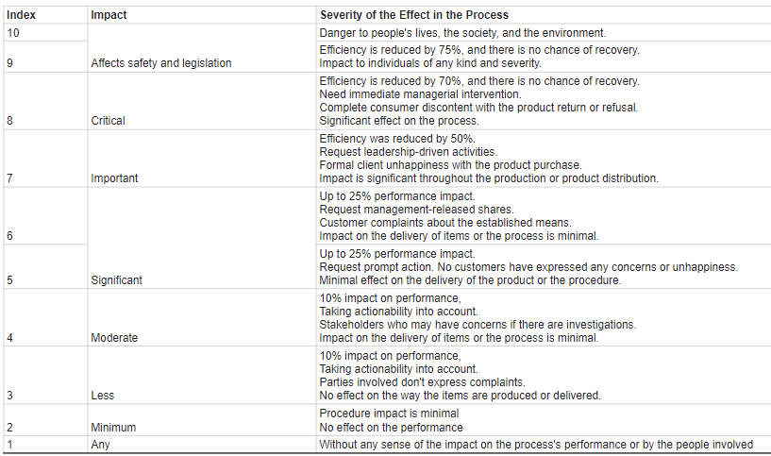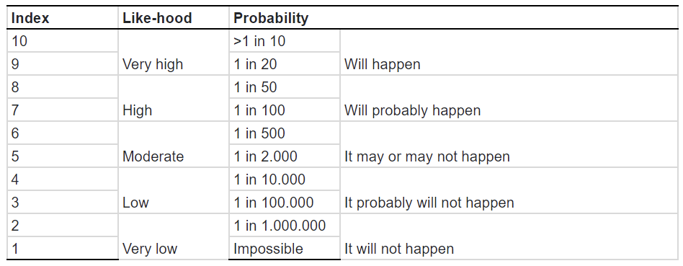

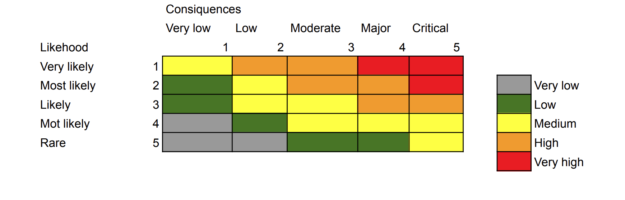

**5 Tracking and Documentation**

The risk manager will send frequent reports, at the very least, once a month. The report should list the accomplishments, ongoing risk management challenges, and actions that have taken place since the last report. All of the factors mentioned, suggestions for risk management actions, and a list of the determined resource requirements for the following financial month should be included in the final risk management report. Risk review sessions should occur once a month, a week before the reporting deadline with the departments involved with the hazards that have already been reported in the same month.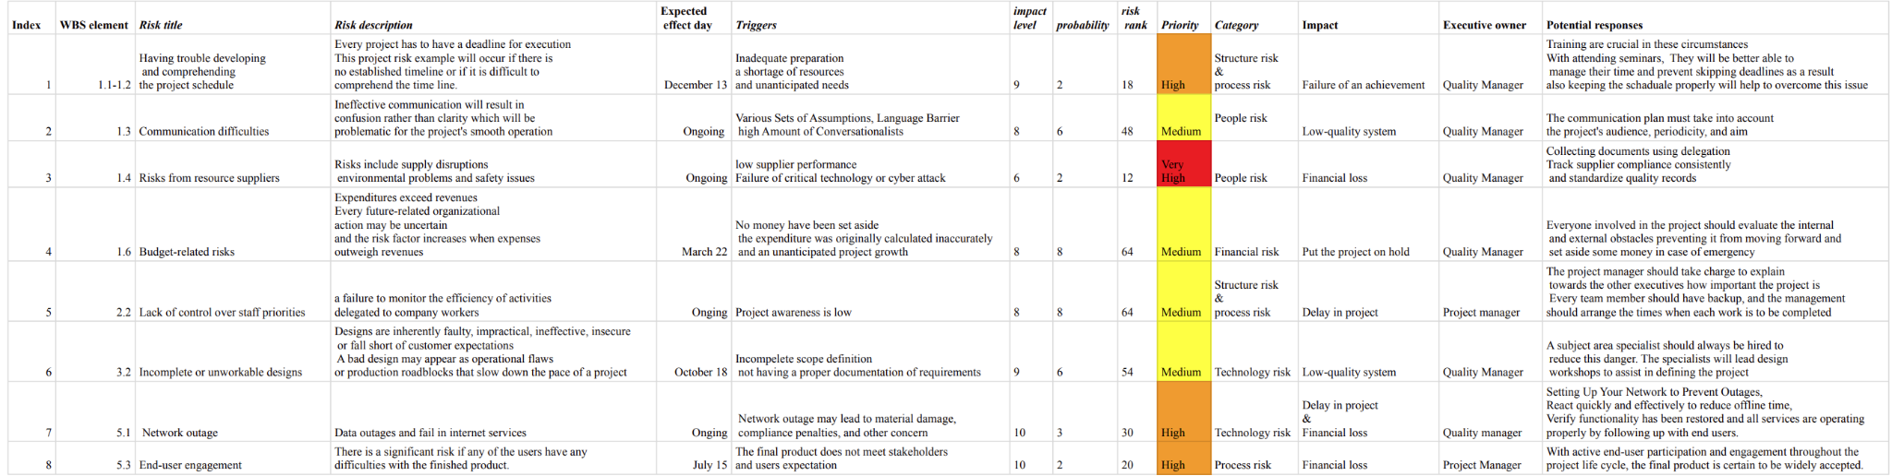

# Procurement Management

“This procurement management plan is provided for the blood bank management system and will be used as a guide for controlling purchases throughout the project's existence and will be modified when procurement requirements change. The procurement of the products, the categories of agreements to be deployed to support the project, the procedure for contract approval, and the decision-making factors are all identified in this plan. “ (Botch, 2018)

"Along with the necessary agency procurement and management professionals, the project director must look into all procurement procedures carried out in accordance with the blood bank management system. All materials that must be purchased for the project to be completed successfully will be determined by the project team and the project director. The Project Steering Committee (PSC) and the project director go over the gathered list for approval. The process entails deciding whether to seek external help and the conditions to request it.” (Botch, 2018)

The work will be done in the ISS’s break-out room. There is no need for more office space.

The project team will use the existing PC-compatible microcomputer in the ISS BOR to complete all coding, testing, and documentation duties.

The execution and performance of the blood bank management project have been assessed to depend on the following procurement of goods and/or services.

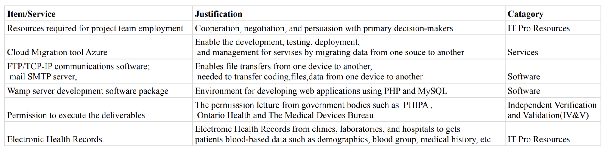

In addition to the previously indicated list of procurement goods, the following individuals and groups are allowed to authorize orders for the entire project:

Human resources department

Executive Team

Steering Committee

Product Manager

Project Manager

“All goods and services that must be purchased for the blood bank management system shall be provided through fixed-price contracts. The project team will specify the item categories, volumes, services, and necessary delivery dates in collaboration with procurement employees. Once a supplier has been chosen, the management group requests it from several suppliers in order to purchase the products within that specified time period and at a fair price under the organization's contract type.” (Botch, 2018)

Following considerations are used to manage the agreements:

-Essential need

-Quality

-Impact on system infrastructure

-Cost

# Stakeholder Management

**Stakeholder management approach**

Key stakeholders for this project include the following people:

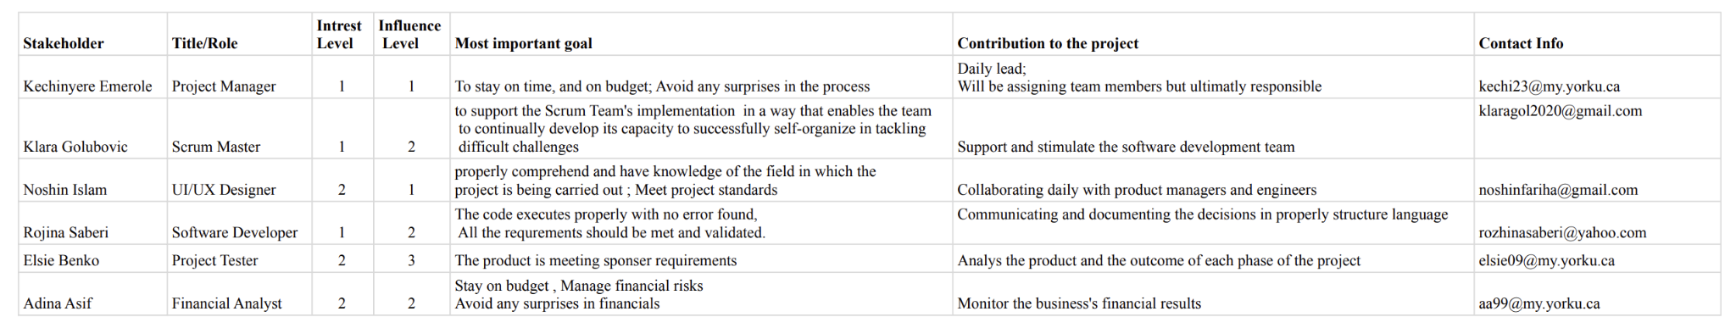

According to the public participation spectrum from the IAP2, we can categorize stakeholder groups into four subcategories based on their power and interest in this software development project.

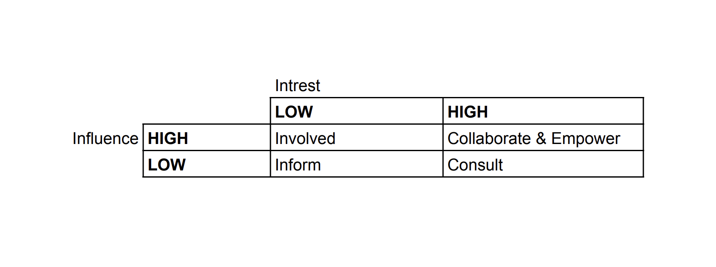

**Stakeholder communication**

Specifications about the communications activities employed throughout the project are defined using the Communications Action Matrix. The project manager creates and updates the matrix however as the project develops, updates or modifications can be needed.

In addition to defining needs and priorities, after all stakeholders have been identified and communication needs determined, stakeholder communication guidelines must also identify the project's communications networks and ensure that contributors have access to them”. All stakeholders must have access to receive project communications. The project team will keep track of this data in the project's Stakeholder Register along with the project communication matrix” (Ahmed Shaikh and Irfan, 2015)

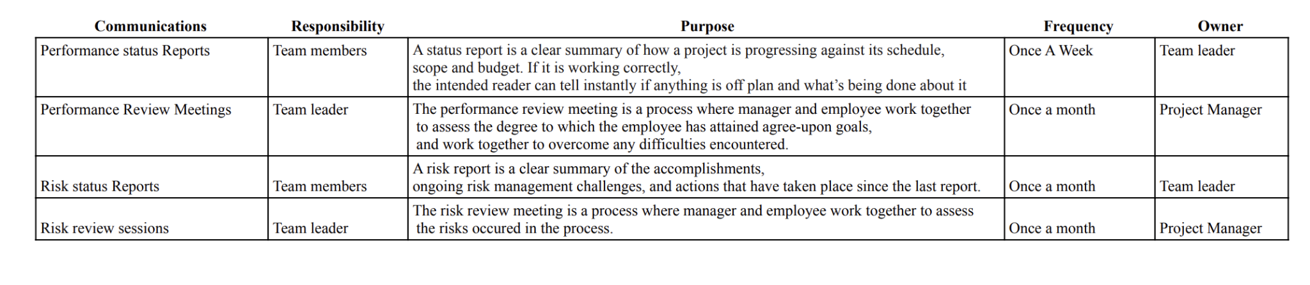

# Team Contribution Composition

| **Team Member Name** | **Percentage of Contribution** | **Description of Contribution** |
| --- | --- | --- |
| Kechinyere Emerole | Equal | Played a part in the cost estimate section using bottom-up analysis, wrote out the front-end section of the WBS, work package and Gantt chart. Submitted all project deliverables. Wrote out and presented all descriptions in item #2 (project integration management) in full project management plan. Transferred WBS content onto project libre for Gantt chart deliverable. Contributed to analysis of option & recommendation in project proposal. Participated in peer-review by assessing the work of other team members to ensure the alignment with project objectives. |
| Noshin Islam | Equal | Incorporated the outline of the project purpose and background into the Project Proposal deliverable, as well as checked for coherence and grammar/punctuation discrepancies through all the deliverables. Completed the Planning and Initiating, Scope Definition and System Analysis in the WBS deliverable. Assisted in completion of the Gantt Chart deliverable and EV Analysis for the Cost Estimation deliverable as well as use Excel to graph the associated costs. Documented the Executive Summary, Schedule Management and Communication Management in the Project Plan and presentation. Participated in all team meetings and organized/planned the meetings to distribute the work for the deliverables. |
| Klara | Equal | Worked on project proposal, WBS and WBS dictionary, came up with the structure and decomposition the WBS, cost estimation (especially: cost estimate, labor estimate), responsible for organization of Gantt chart (chose Instagantt as cloud based tool, prepared structure, implemented table, prepared first WBS items), idea finding and definition of business, participated in every team meeting and organized/planned the meetings to distribute the work for the deliverables, wrote out first points of #3 scope management for full project management plan and presentation, helped and organized preparation for the PowerPoint presentation |
| Elsie Benko | Equal | Contributed to every deliverable such as the project proposal, WBS and WBS Dictionary and the Gantt chart (especially Defining Requirements and Planning and Initiating), the EV Analysis and Labor Estimate in the cost estimate, and the full plan which consisted of half of part 3 (Scope management) and 7 (Human resources management). I also helped schedule meetings and attended each one. |
| Rozhina Saberi | Equal | Contributed in every deliverable such as the project proposal, WBS and WBS Dictionary and the Gantt chart (specially EV analysis in cost estimate) Wrote out and presented all descriptions in risk management, procurement management and stakeholder management in project full plan. |
| Adina Asif | Equal | Contributed to every deliverable and attended all group meetings. Contributed to the approval authority and financials in the project proposal deliverable. Completed #6 Integration and testing in the WBS deliverable. Integrated the #5 Integration and testing in the Gantt chart. Also helped format the Gantt chart from Instagantt to project Libre. Concluded with contributing to the Cost management and Quality Management in the Project plan and presentation. |

# Description of Revisions

No changes were made to the full project management plan that differ from the previously submitted deliverables.

**13 References**

The following documents are attached to this Project Plan for immediate reference.

|  |  |  |  |
| --- | --- | --- | --- |
| **Appendix** | **Document Name** | **Version** | **Date** |
| A | Work Breakdown Structure and Dictionary | 1.4 | 26.11.2022 |
| B | Gantt Chart | 1 | 01.11.2022 |
| C |  |  |  |
| Etc |  |  |  |

**References**

Art of communication in project management. (n.d.). www.pmi.org. <https://www.pmi.org/learning/library/effective-communication-better-project-management-6480#:~:text=A%20communications%20management%20plan%20can>

Barron, M., Barron, A., Resources, P. M. O., TAP-a-PM, & Watt, A. (2014, August 14). *12. budget planning*. Project Management 2nd Edition. Retrieved November 27, 2022, from <https://opentextbc.ca/projectmanagement/chapter/chapter-12-budget-planning-project-management/>

Belgodere, M., Claustre, J., Comte,, C., Diallo,, A., Wamal., C., Sugden, L., . . . Latge, E. (2022, August 16). Risk management team roles: Who takes care of project risk? Retrieved November 29, 2022, from <https://www.migso-pcubed.com/blog/pmo-project-delivery/risk-management-team-roles/>

Bilyana. (2022, October 14). *Change Control Process in Project Management: What, How and Why - Inside Kitchen*. Inside Kitchen. <https://kitchen.co/blog/change-control-process-in-project-management/>

Blood donation process at Canadian Blood Services. (n.d.). Www.blood.ca. <https://www.blood.ca/en/blood/donating-blood/donation-process>

Bourne, L. (2012, April 4). Stakeholder risk tolerance - project management articles for ... Retrieved November 29, 2022, from <https://pmhut.com/stakeholder-risk-tolerance>

Brown, L. (2021, June 10). *Perform Integrated Change Control: Input, Output, & Tools Used*. Invensis Learning Blog; <https://www.facebook.com/invensislearn/.><https://www.invensislearning.com/blog/perform-integrated-change-control/>

Brown, L. (2021, June 16). Project Schedule Management: How to Plan, Develop, Maintain & Control? Invensis Learning Blog. <https://www.invensislearning.com/blog/project-schedule-management/>

B. (2018, October 21). Procurement management plan. Retrieved November 29, 2022, from <https://www.scribd.com/document/391268923/Procurement-Management-Plan>

*Change Management Tools and Techniques: The Complete List*. (2019, August 20). Daniel Lock’s Blog. <https://daniellock.com/change-management-tools/#Flowcharting>

*Closing a Project or Phase | Project Management Professional (PMP)*. (n.d.). Online Professional Certifications Training Provider | GreyCampus. Retrieved November 26, 2022, from <https://www.greycampus.com/opencampus/project-management-professional/closing-a-project-or-phase>

Cussen M. P., The Top Challenges Financial Advisors Face. (2019). Retrieved from Investopedia website: <https://www.investopedia.com/articles/financial-advisor/052516/top-challenges-financial-advisors.asp>

*Continuous integration with agile*. BrowserStack. (2020, October 16). Retrieved November 28, 2022, from <https://www.browserstack.com/guide/continuous-integration-with-agile>

3, D. (2022, January 25). Understanding risk management in software development: 7 common risks. from <https://www.door3.com/blog/understanding-risk-management-in-software-development-7-common-risks>

*Develop App Like Oscar Healthcare App + PHIPA Requirements*. (2020, May 7). SyS Creations - IT Management, Compliance & Consulting Company in Canada. <https://www.syscreations.ca/blog/phipa-ontario-requirements-to-develop-oscar-healthcare-app/>

*Earned Value Management Systems (EVMS) - Project Management Institute*. (n.d.). Retrieved November 27, 2022, from <https://www.pmi.org/learning/library/earned-value-management-systems-analysis-8026>

*Frequently asked questions - IPC*. (n.d.). Retrieved November 26, 2022, from <https://www.ipc.on.ca/wp-content/uploads/2015/11/phipa-faq.pdf>

*How to ensure an efficient software quality management process*. BrowserStack. (2022, April 18). Retrieved November 28, 2022, from <https://www.browserstack.com/guide/efficient-software-quality-management-process>

*How to use bottom-up estimating: A step-by-step guide*. The Motley Fool. (2022, August 5). Retrieved November 27, 2022, from <https://www.fool.com/the-ascent/small-business/project-management/articles/bottom-up-estimating/#:~:text=Bottom%2Dup%20estimating%20is%20a,be%20delegated%20to%20team%20members>.

IT System Integration Challenges. (2020, October 22). Litcom. <https://www.litcom.ca/it-system-integration-challenges/>

Kissflow. (2019, December 12). 9 Project Management Challenges and How to Overcome Them. Kissflow. <https://kissflow.com/project/project-management-challenges/>

Lucid Content Team. (2018, December 19). How to Write a Project Management Communication Plan | Lucidchart Blog. Lucidchart.com. <https://www.lucidchart.com/blog/project-management-communication-plan>

Malsam, W. (2022, November 9). *The Quality Management Plan in project management*. ProjectManager. Retrieved November 27, 2022, from <https://www.projectmanager.com/blog/quality-management-plan#:~:text=What%20Is%20a%20Quality%20Management,and%20meeting%20the%20customer's%20needs>.

Mojica, R. (2018, June 19). *Projectmanagement.com - change management process for Project*. Projectmanagement.com. Retrieved November 26, 2022, from <https://www.projectmanagement.com/wikis/396744/Change-Management-Process-for-Project>

PMG | Issue Management - Description. (n.d.). Retrieved November 26, 2022, from <https://www2a.cdc.gov/cdcup/library/pmg/other/isu_description.htm#:~:text=The%20purpose%20>

*7 Steps to Nail the Project Management Closure Process | Lucidchart Blog*. (2019, August 19). Lucidchart. <https://www.lucidchart.com/blog/nailing-the-project-management-closure-process>

*Quality Management for large software development programs*. (n.d.). Retrieved November 27, 2022, from <https://www.pmi.org/learning/library/quality-management-software-development-programs-1059>

Shaikh, H. (2015, October 21). Communication management plan. Retrieved November 29, 2022, from <https://www.academia.edu/17119487/Communication_management_plan>

Shaikh, H. (2015, October 21). Stakeholder management plan. Retrieved November 29, 2022, from <https://www.academia.edu/17119460/Stakeholder_management_plan>

Simmons, M. (2021, August 5). 5 Essential Tips for Schedule Control in Project Management. ProjectManager. <https://www.projectmanager.com/blog/schedule-control-tips#:~:text=What%20Is%20Schedule%20Control%3F>

Sss, S. (2019, April 12). Blood donation management system. Retrieved November 29, 2022, from <https://www.academia.edu/38786723/Blood_Donation_Management_System>

*7 Steps to Nail the Project Management Closure Process | Lucidchart Blog*. (2019, August 19). Lucidchart. <https://www.lucidchart.com/blog/nailing-the-project-management-closure-process>

Top Challenges of Enterprise, Software and Solution Architects – SoftwareArchitect.ca. (n.d.). <https://softwarearchitect.ca/top-challenges-of-enterprise-software-and-solution-architects/>

Task, productivity and time management knowledge base. (n.d.). [www.taskmanagementguide.com.](http://www.taskmanagementguide.com.) <http://www.taskmanagementguide.com/>

Rudder, A. (2022, July 25). *What Is A Project Management Plan? – Forbes Advisor*. Forbes Advisor. <https://www.forbes.com/advisor/business/project-management-plan/>

Schwalbe, K. (2019). *Information Technology Project Management*. Cengage.

*Ultimate Guide to Project Cost Estimating*. Smartsheet. (2017, March 27). Retrieved November 27, 2022, from <https://www.smartsheet.com/ultimate-guide-project-cost-estimating>

Usmani, F. (2022, September 16). *Assumptions and constraints in project management*. Home Page. Retrieved from <https://pmstudycircle.com/assumptions-and-constraints-in-project-management/>

Westland, J. (2022, February 14). *What Is Change Control in Project Management?* ProjectManager; <https://www.facebook.com/projectmanage/.> <https://www.projectmanager.com/blog/what-is-change-control-in-project-management>

What Is FTP? File Transfer Protocol explained. (n.d.). SearchNetworking. <https://www.techtarget.com/searchnetworking/definition/File-Transfer-Protocol-FTP>

Zhang, I. (2014, September 23). Stakeholder management plan. Retrieved November 29, 2022, from <https://www.academia.edu/8461019/Stakeholder_Management_plan>